Assignment 13.3
Question 1
Problem Statement
● Find square root of number using Babylonian method.
1 Start with an arbitrary positive start value x (the closer to the
root, the better).
2 Initialize y = 1.
3. Do following until desired approximation is achieved.
a) Get the next approximation for root using average of x and y
b) Set y = n/x
Step: first of all will create a scala objet with the name as square root and will click finish
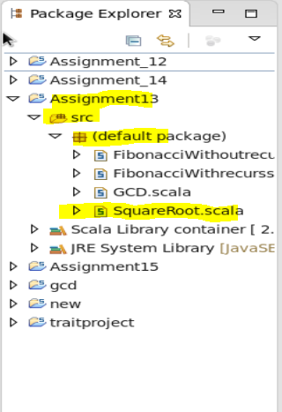
Wil do the programming code as required for the logic of finding square root by the methid
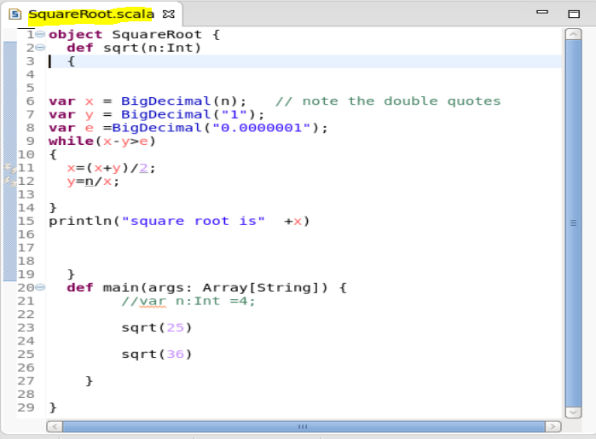
Now after writing the cide will save it and run as scala application

The output will be as
